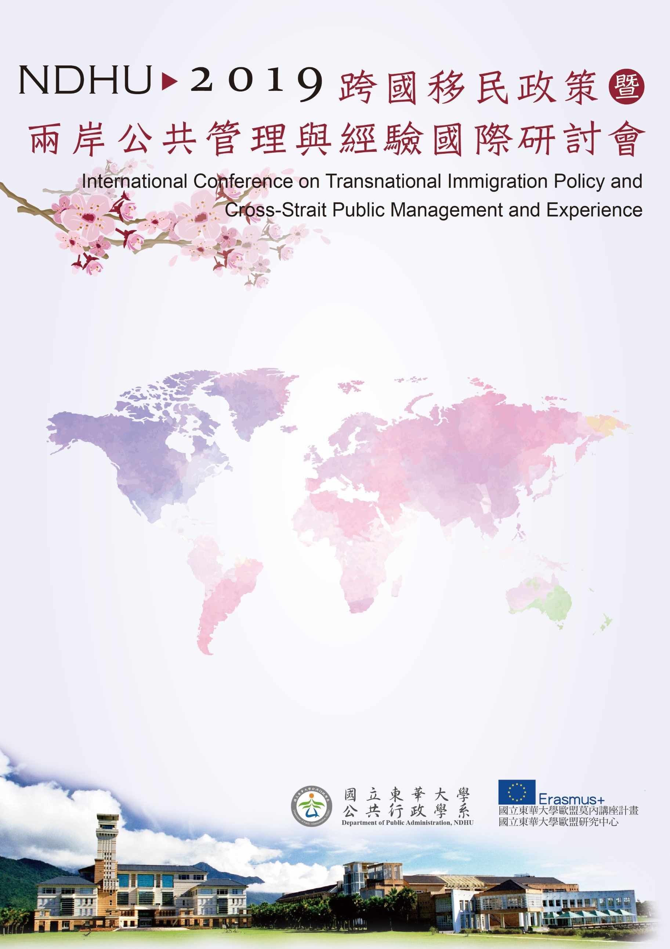

會議地點：國立東華大學人社一館A207會議室
Conference Room A207, College of Humanities and Social Sciences, NDHU
第四場論壇Session IV
15:40~17:20
Panel E3:
Transnational Immigration Policy – Comparison between Europe and Asia
Moderator：石忠山主任 Prof. Chung-shan Shih, Director of Department of Public Administration, NDHU, Taiwan
Political rights of Immigrants
Prof. Dr. Minjeoung Kim, Professor of Dept. International Relations University of Seoul, Korea
A Study on Migration Policy in Japan
Prof. Dr. Sang-Chul Park, Director of Center for Supporting Small Champion Corporations, Graduate School of Knowledge based Technology and Energy, Korea Polytechnic University
Is Migration changing the game? On the development of the German Party system
Prof. Dr. Eike-Christian Hornig, Assistant Professo of Institute of Political Science, Justus-Liebig University Giessen, Germany
Discussant:
Prof. Dr. Dieter Eissel, Justus-Liebig-University Giessen, EU Erasmus Coordinator, Germany
Prof. Yun-Hsiang, Tien, School of Political Science and Public Administration，Wuhan University, China

