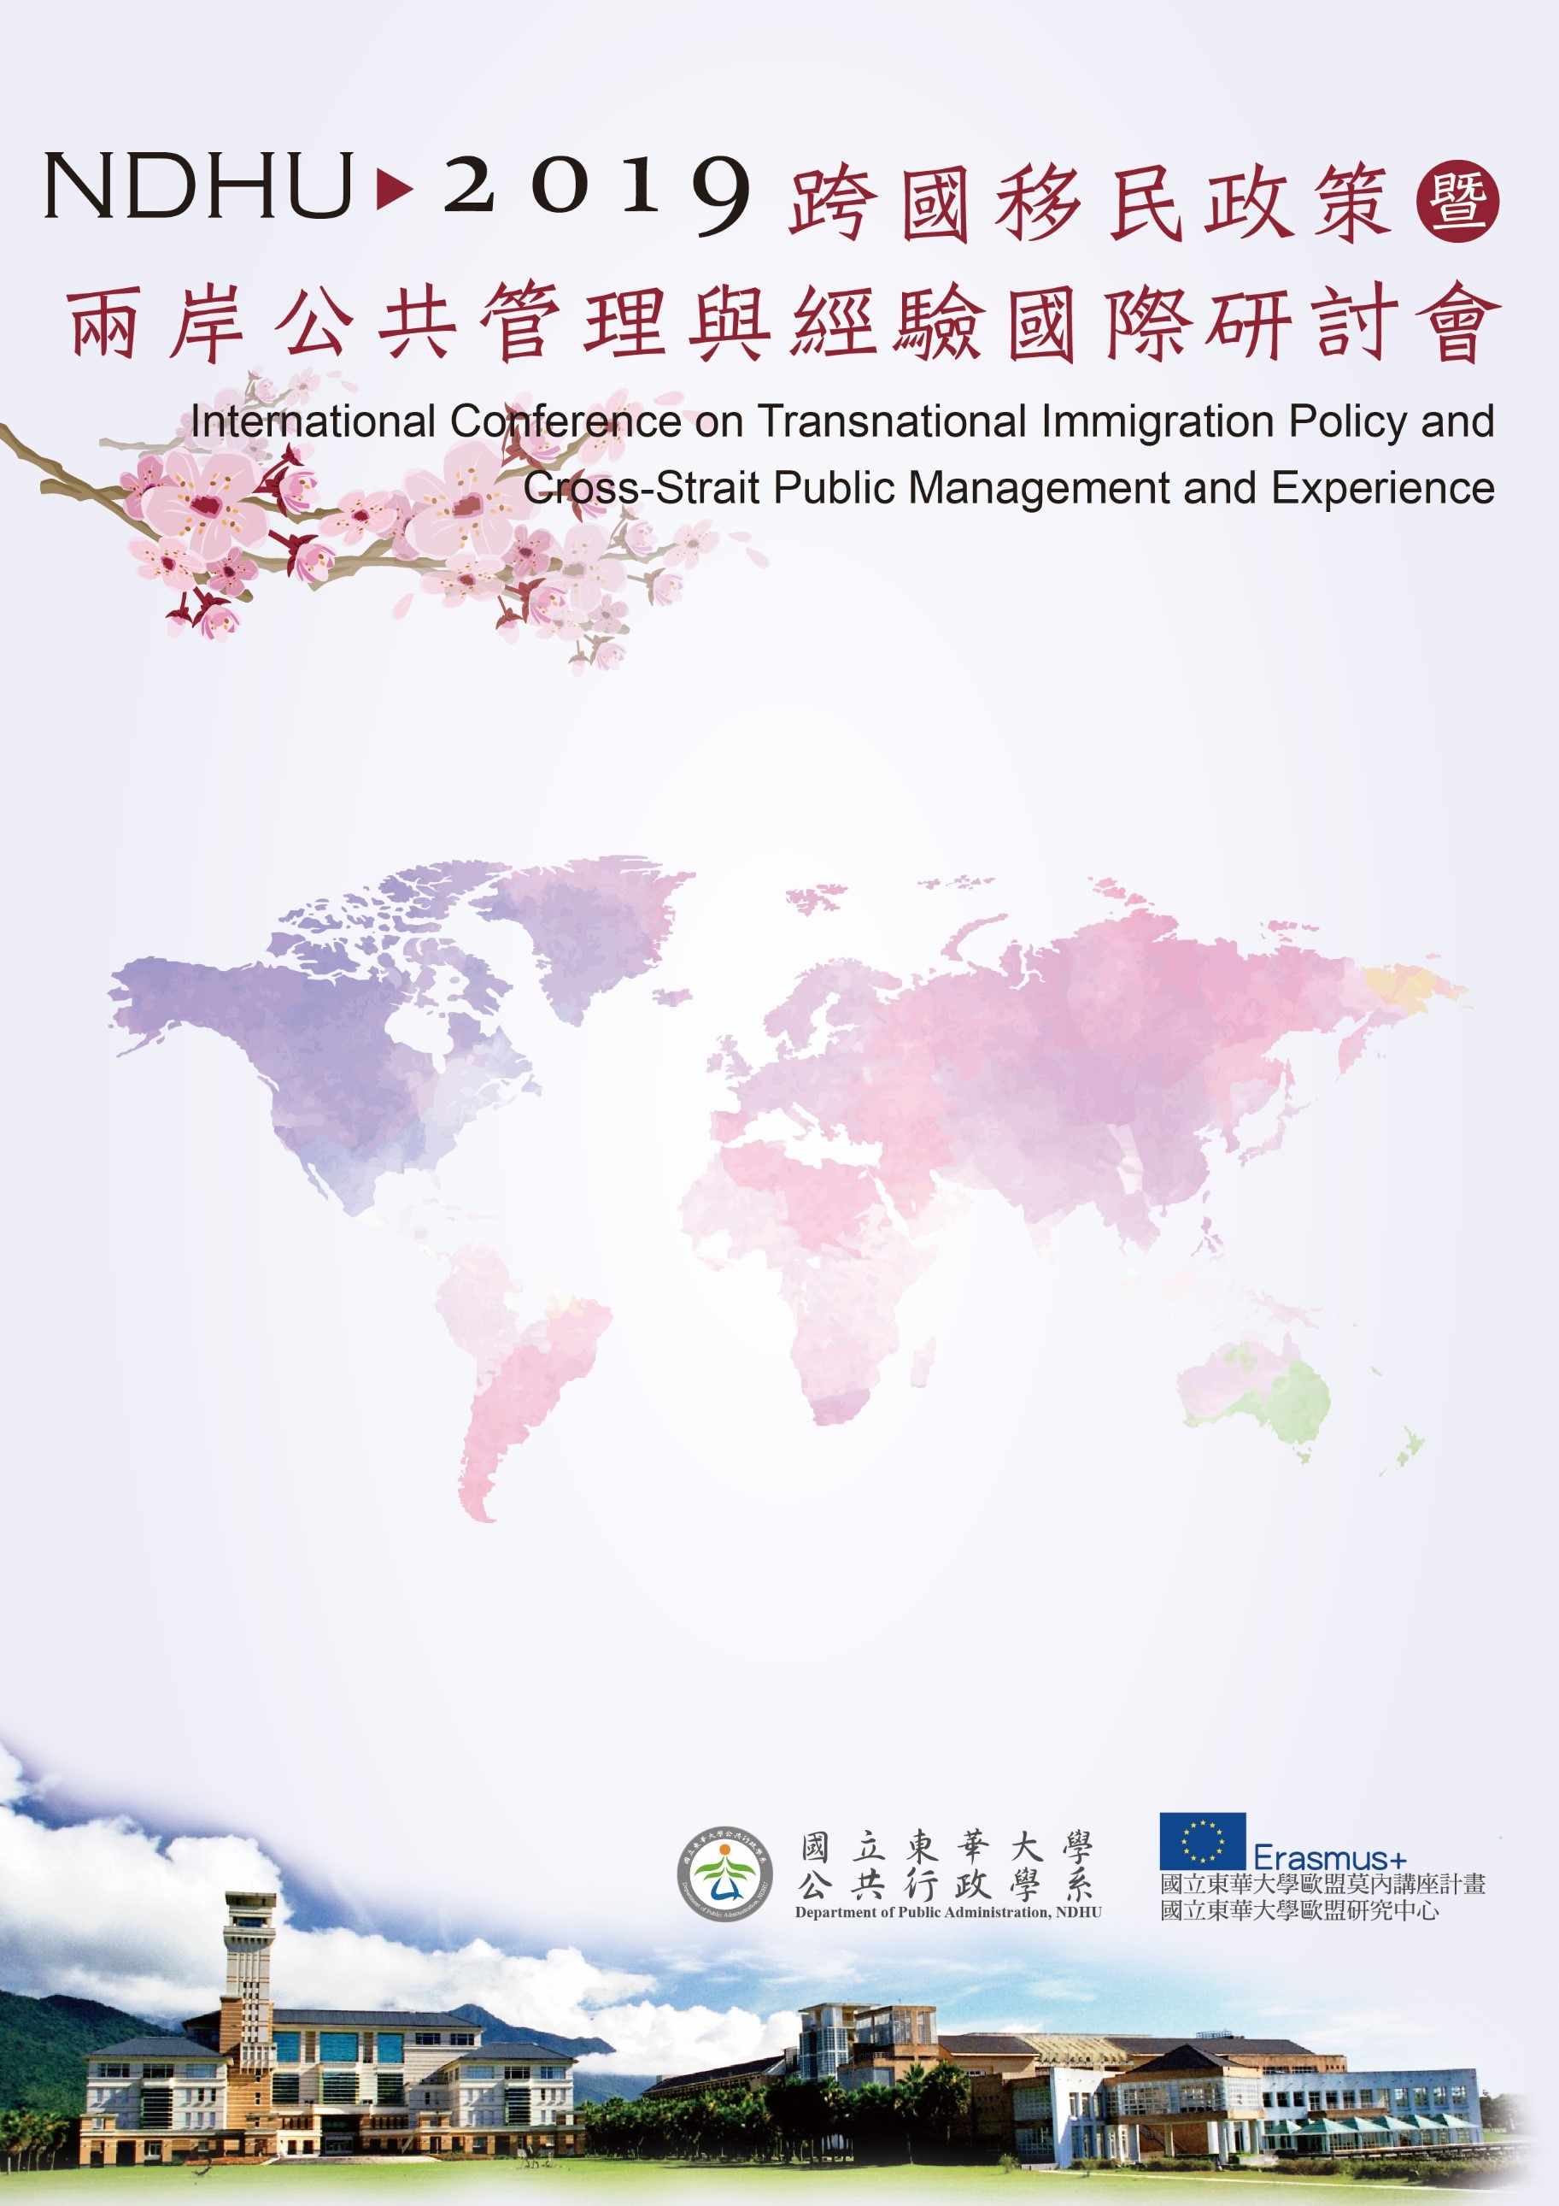

會議地點：國立東華大學人社一館A207會議室
Conference Room A207, College of Humanities and Social Sciences, NDHU
第三場論壇Session III
13:30~15:10
Panel E2:
Transnational Immigration Policy–Taiwan’s Experience and New South bound policy
Moderator：蘇彩足教授Prof. Tsai-Tsu Su, Department of Political Science, and Graduate Institute of Public Affairs, National Taiwan University, Taiwan
Determinants of Taiwan's Youth Employment and Entrepreneurship in China and Southeast Asia
Prof. Kuo-Chun Yeh, Professor of Graduate Institute of National Development, National Taiwan University, Taiwan
The Nexus between Foreign Labor Policy and Human Trafficking in Taiwan
Prof. Wen-Chih Billy Huang, Assistant Professor of Department of Border Police, Central Police University, Taiwan
Thailand Immigrant Policy: The Challenge and Opportunity before and after ASEANIZATION
Mr. Prateep(Patrick) Chaylee, PhD. Student of Institute of China & Asia Pacific Studies, National Sun Yat-sen University
Labor Immigration Policy in Vietnam
Ms. Ngoc-Tram Dang, Head, Division of General and External Issues, National Center for Socio-Economic Information and Forecast, Ministry of Planning and Investment, Vietnam
Discussant:
Prof. Dr. Eike-Christian Hornig, Professor of Institute of Political Science, Darmstadt Technical University, Germany
Prof. Chu-Bo, Yu, Director of Department of E-Government, School of Public Administration, Jilin University, China

