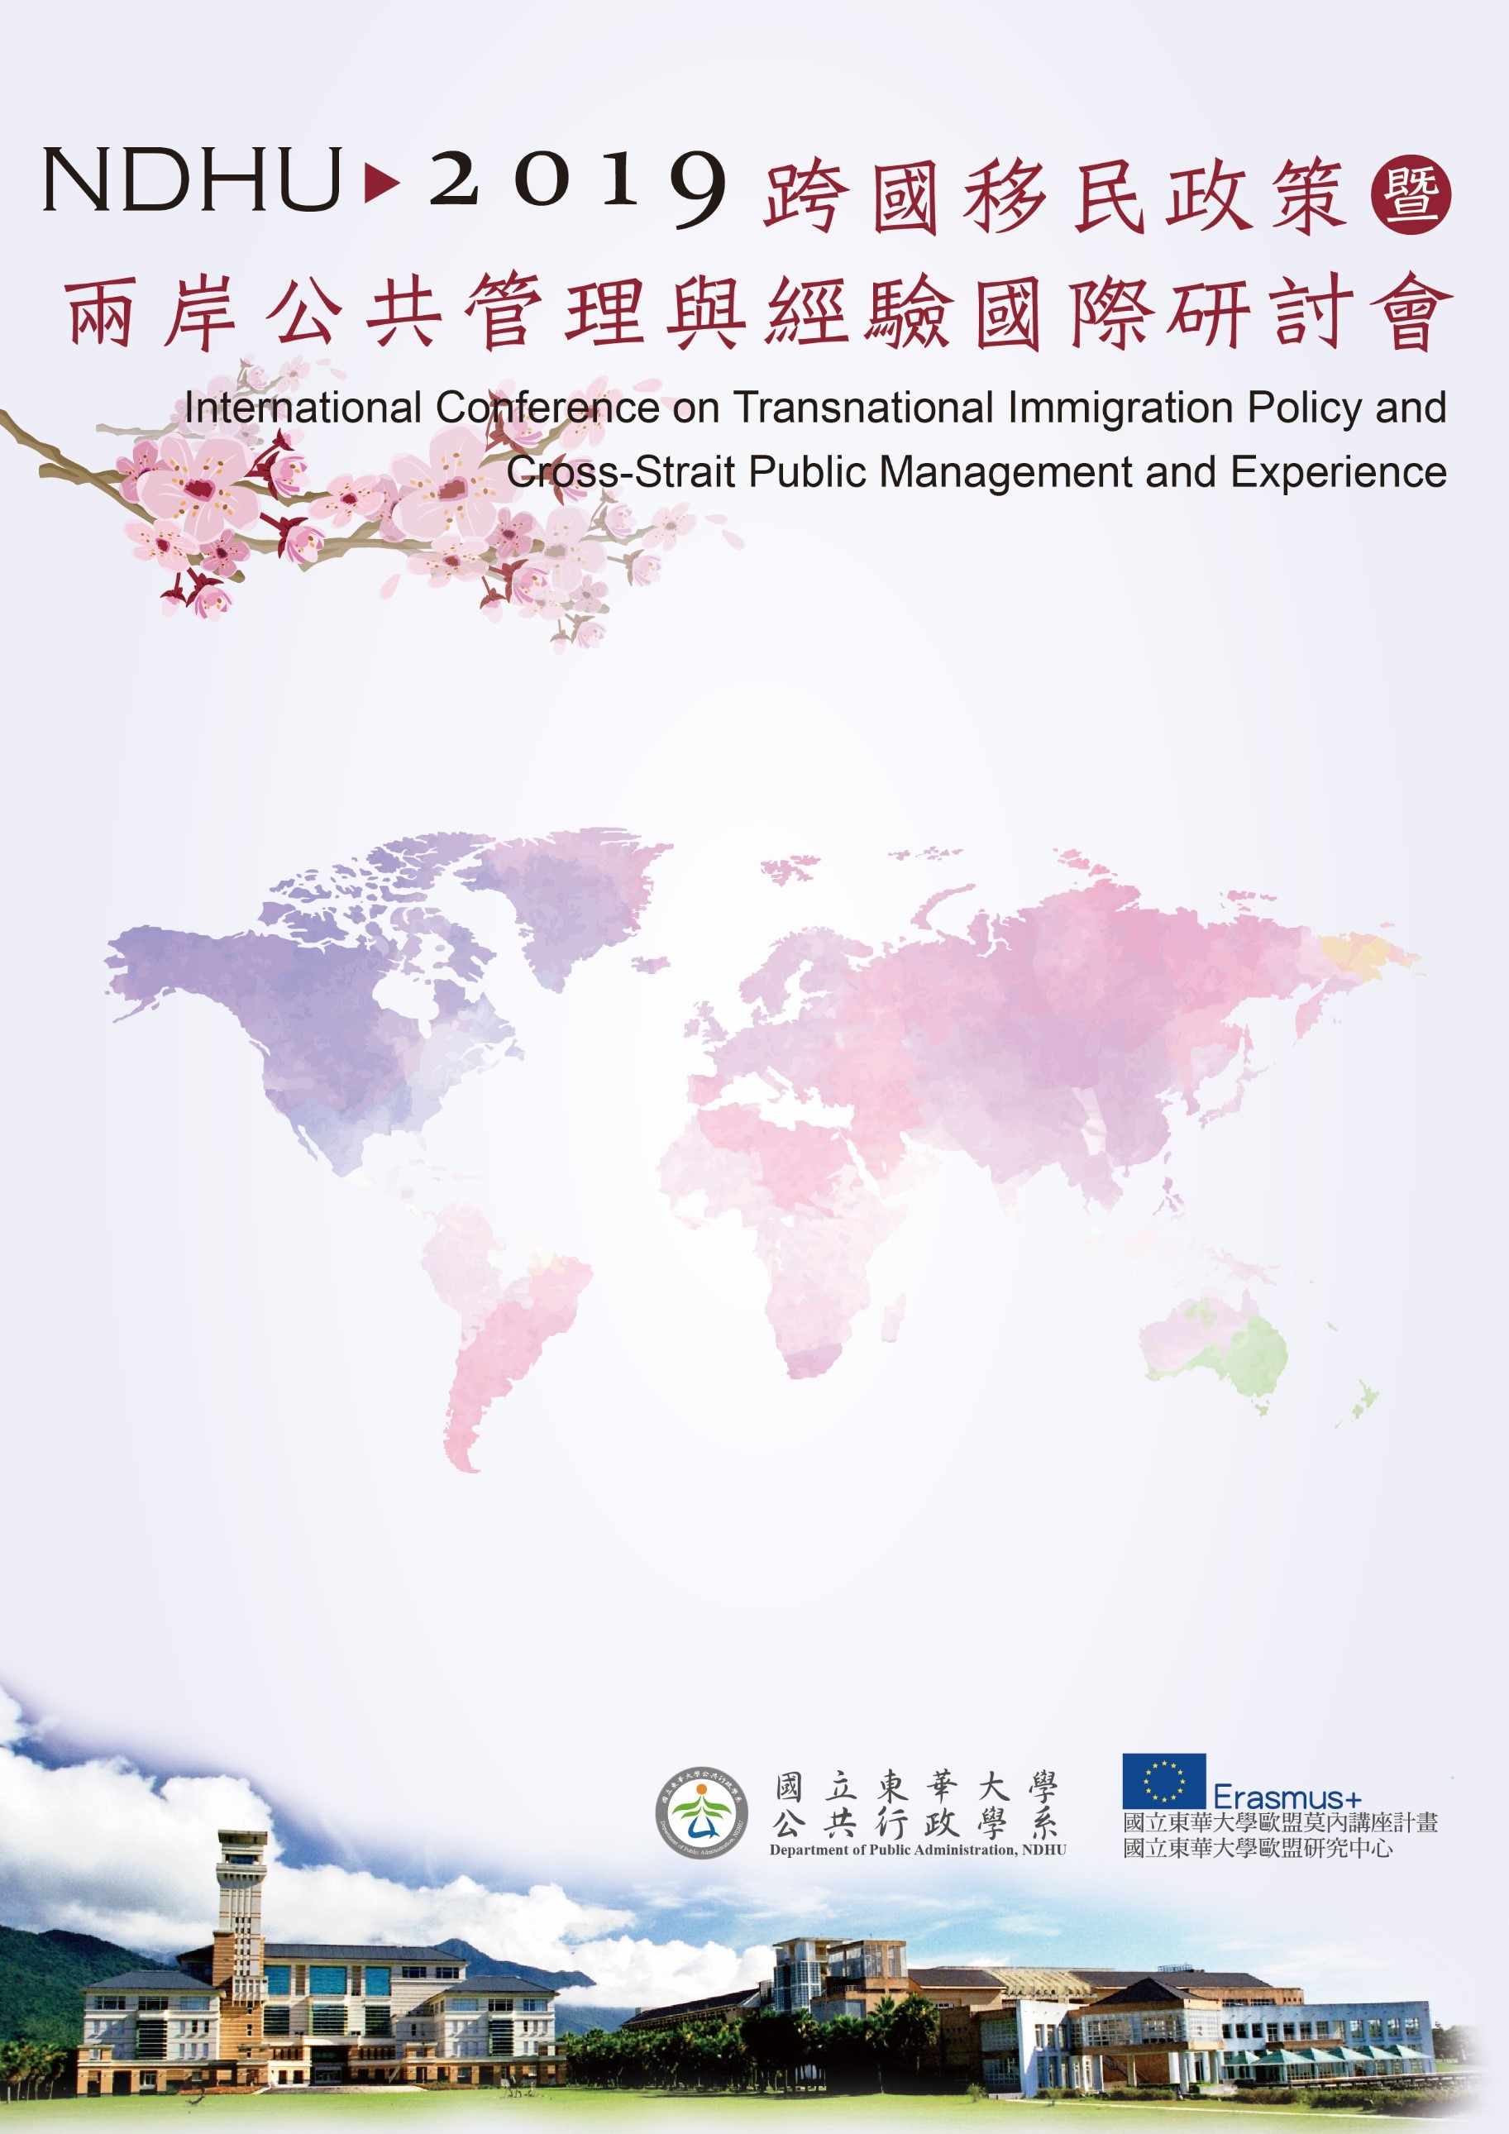

會議地點：國立東華大學人社一館A207會議室
Conference Room A207, College of Humanities and Social Sciences, NDHU
第二場論壇Session II
10:50~12:30
Panel E1:
Transnational Immigration Policy - EU Experience
Moderator：黃朝盟院長 Prof. Chaomeng James Huang, Dean of College of Public Affair, National Taipei University, Taiwan
Immigration to Europe: Conditions and Reactions
Prof. Dr. Dieter Eissel, Justus-Liebig University Giessen, EU Erasmus Coordinator, Germany
The influence of Estonian immigration policy on the development of the Estonian asylum system
Ms. Mariliis Trei, PhD. Student in Department of Public Management and Policy, Tallinn University of Technology, Estonia
Immigration policy of Eastern Europe. The case of Poland and Hungary
Prof. Dr. Ewa Rokicka, Department of Sociology of Social Structure and Social Change, Faculty of Economics and Sociology, University of Lodz, Poland
Discussant:
Prof. Dr. Sang-Chul Park, Director of Center for Supporting Small Champion Corporations, Graduate School of Knowledge based Technology and Energy, Korea Polytechnic University
Prof. Ming-Feng Liu, Department of International and Mainland China Affairs, National Quemoy University

