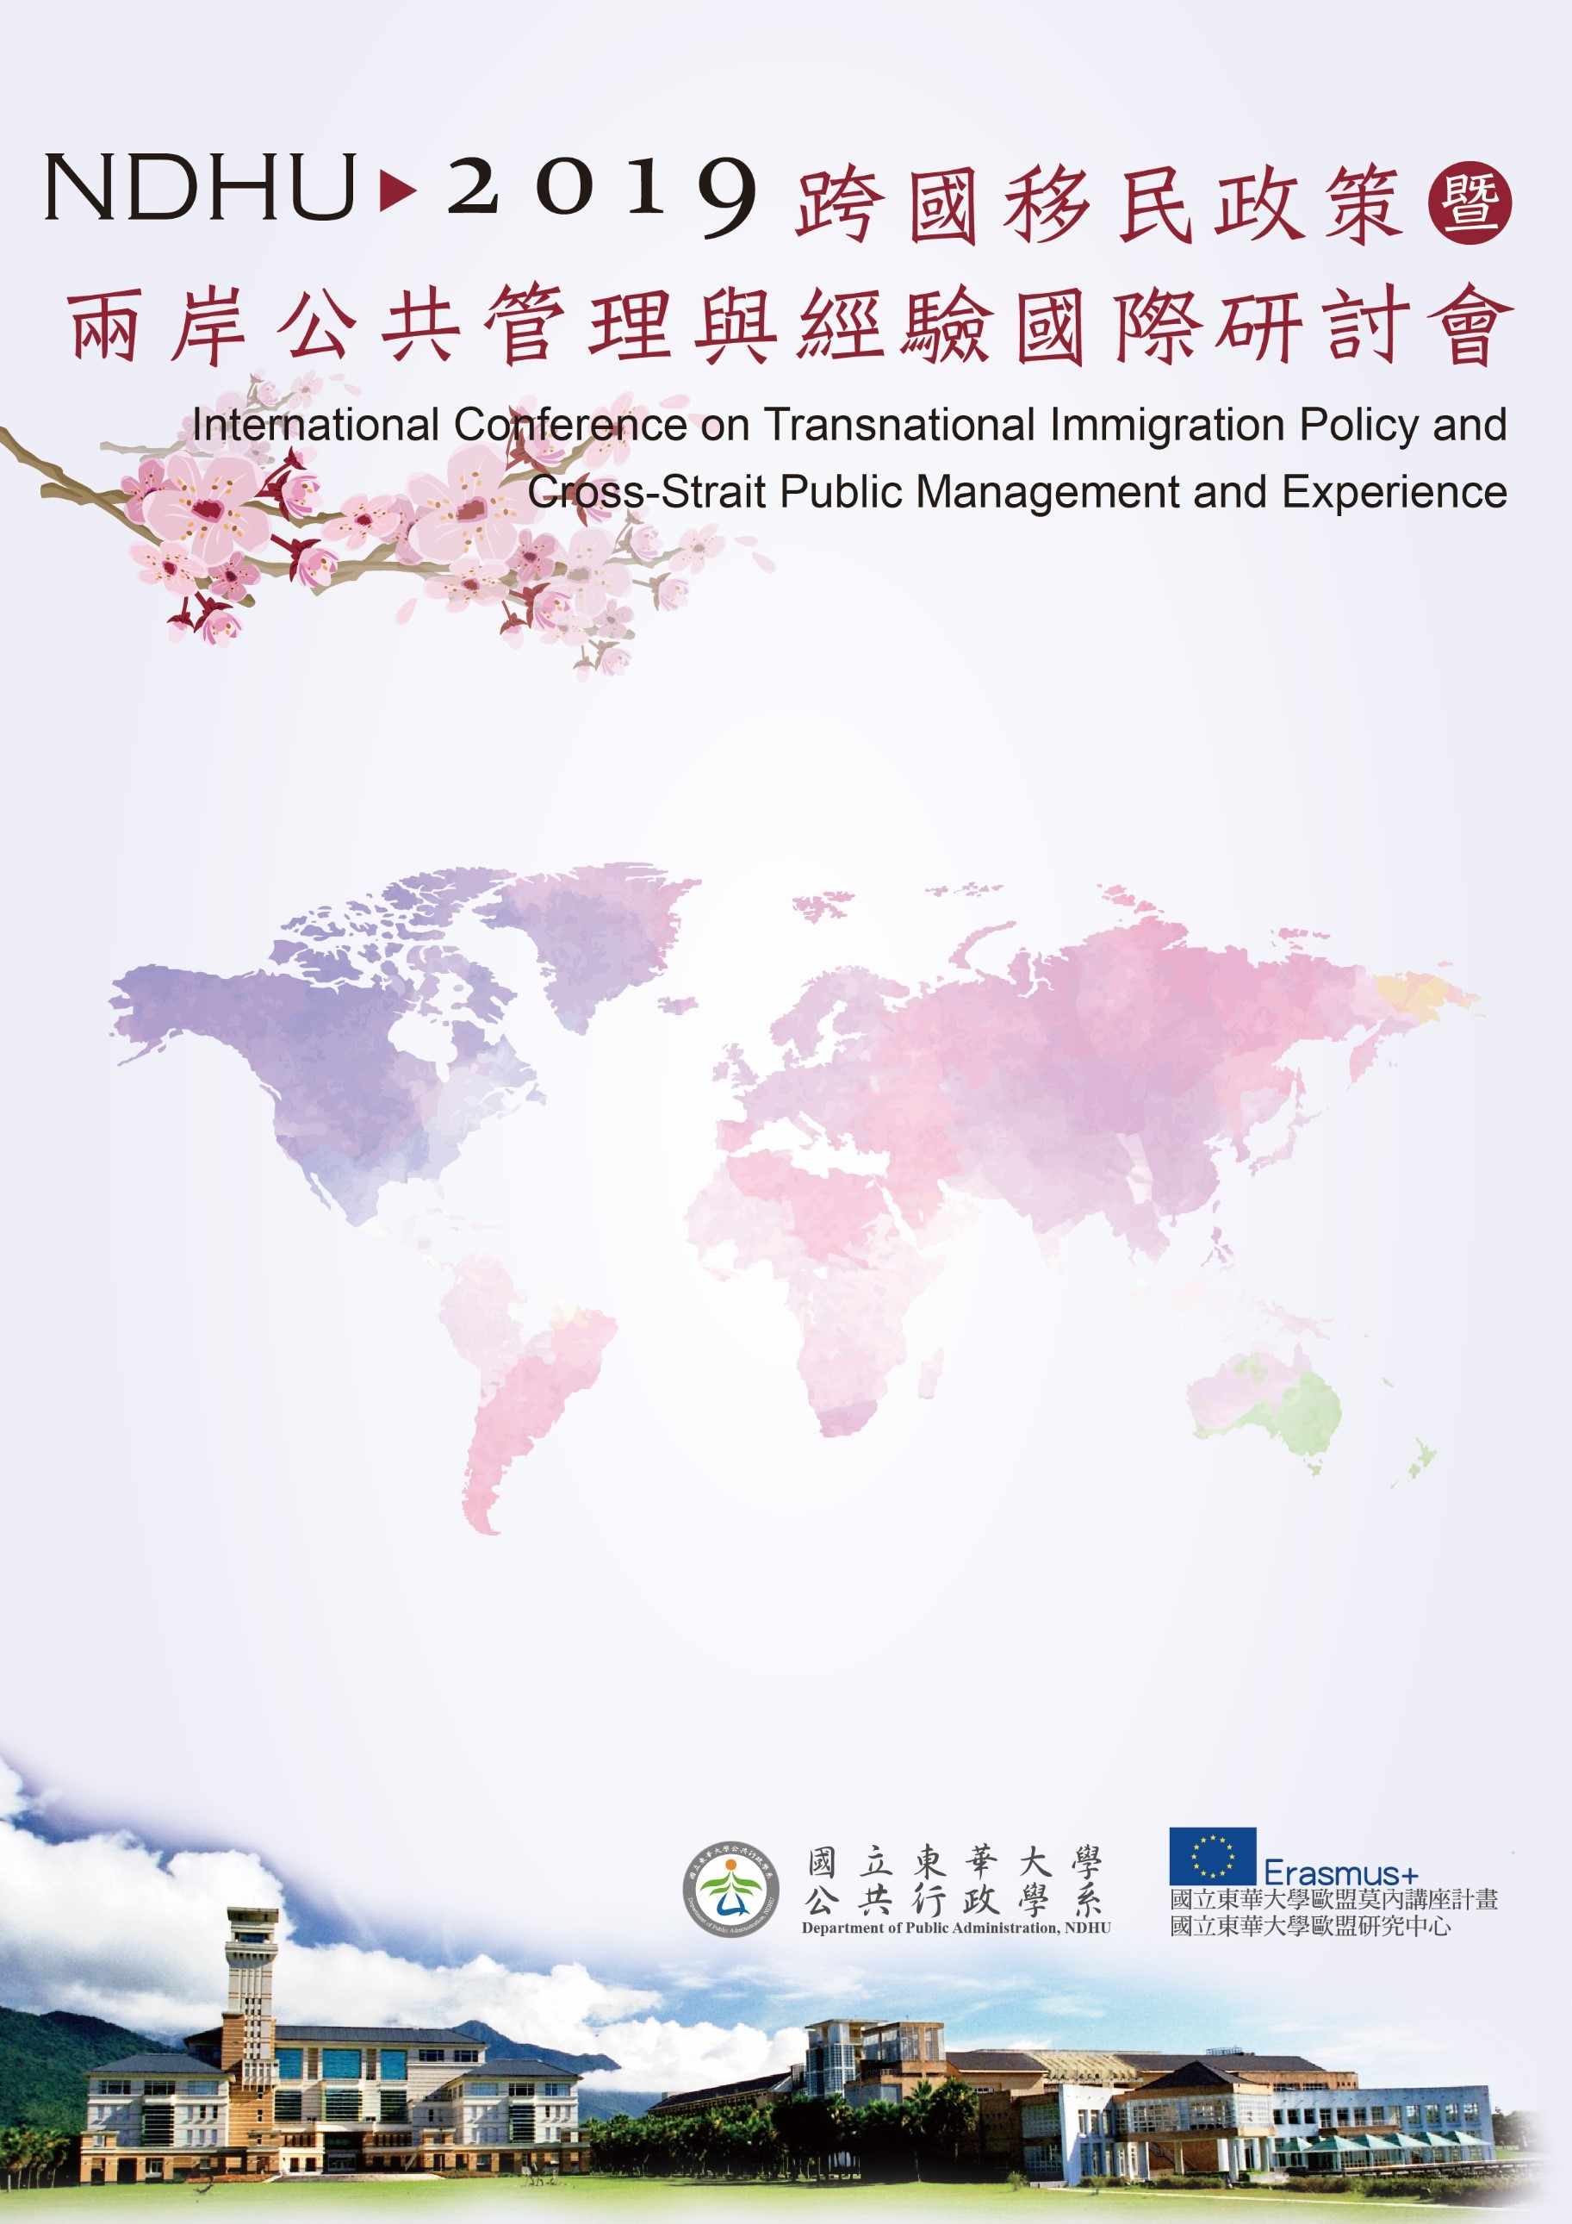

會議地點/ Venue：國立東華大學人社一館第一講堂/1st
Lecture Hall, College of Humanities and Social Sciences, NDHU
09:00~09:30 | 報到 Regitration
09:30~10:00 | 開幕式 Opening Address
與會貴賓致詞
主持人(Moderator)：朱景鵬副校長(研討會籌備委員會召集人)/Prof. Chin-peng Chu(Vice President/NDHU)
第一場論壇  Session I  10:00~10:30 | 主題演講 Invited Speeches
我國移民政策的現況與展望Current Situation and Prospects of Immigration Policy in Taiwan
張琬宜司長 Ms. Wan-Yi Chang, General Director of Department of Household Registration, Ministry of the Interior, Taiwan

